Amadeusz Deutry

File System Documentation

**OVERVIEW**

A filesystem provides an operating system with the ability to read, write, and modify files on secondary storage devices. The responsibilities of an effective file system include the proper management of files and directories and minimizing the possibility of corrupt or damaged data. A file system should also provide the operating system with and user with a convenient and reliable interface which is able to perform operations on the directories and files already on the filesystem.

**DESIGN**

For my implementation of a filesystem I chose to follow the design of the FAT32 filesystem. The file system itself is stored in one file on a real machine. This file is separated into 3 parts: the boot sector, the FAT table, and the data section. (Traditional FAT filesystem implementations include two FAT tables for consistency but only one is included in this implementation.)

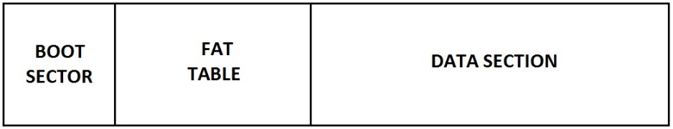

The boot sector contains the size of the filesystem, the starting offset of the FAT table, and the starting offset of the data section.

**IMPLEMENTATION**

**FUNCTIONS**